**LABSHEET 05**

**ID NO: IT24101721**

**Gunasinghe N A L**

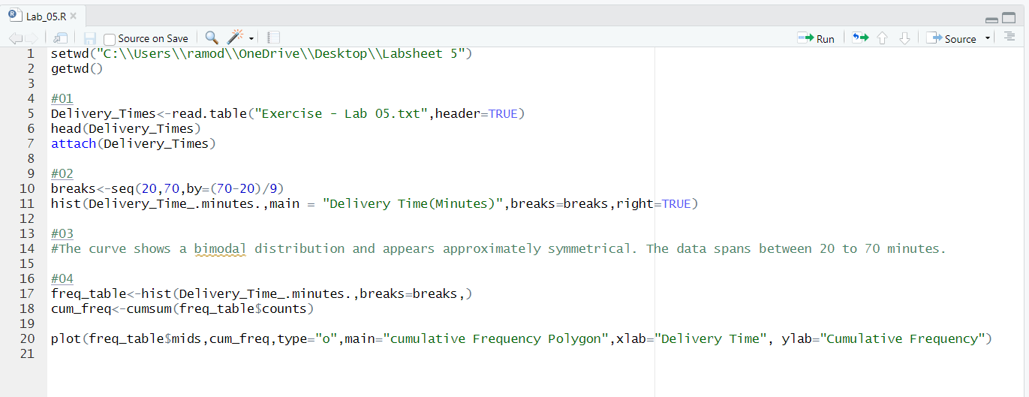

Question 03

* The curve shows a bimodal distribution and appears approximately symmetrical. The data spans between 20 to 70 minutes.



